USER’S

MANUAL

MuckDuck: Space Shooter

EECS 448 – Software Engineering Project 4

May, 2019
USER'S MANUAL

TABLE OF CONTENTS

Page #

1.0 INTRODUCTION
1.1 Dedication
1.2 Overview
2.0 GAME SETUP and PLAY
2.1 Main Menu
2.2 Game Play 2-2
2.3 Test Suite 2-4
3.0 REFERENCES and CITATIONS
3.1 Citations

1.0 Introduction

Introduction

1.1 Dedication

We would like to dedicate the creation of this project to our beloved professor, Paul Kline. Without his support and guidance, we would not have been able to complete this project. We would like to thank him for his time and patience as we worked diligently to make this dream a reality. Additionally, we would like to thank Oqi, our Lab TA for helping us and being such a strong pillar of support. Thank you for helping us in lab and allowing us the freedom to choose how we worked on this project. Last but not least, thank you to all our peers, friends, and family for always supporting us in all our endeavors.

1.1 Overview

MuckDuck: Space Shooter was created using Unity software. It was designed as an old school arcade game. It follows a “Shoot-em up” genre style. The origin of the name comes from a reference to the popular American television show “The Office”. In this episode, the characters Oscar and Dwight discuss the importance of the letter “R” and how dangerous this letter makes a word sound. In response to something Oscar says, Dwight answers “That’s why it’s called MURDER not MUCKDUCK”.

And thus…. our game was born.

The objective of MuckDuck: Space Shooter is to destroy the random spawning enemy bees with the duck’s laser shooter. Every 400 points, an enemy Queen Bee boss is released. The Enemy queen can shoot projectiles as well. The Duck has 3 lives to try to beat its high score.

2.0 GAME SETUP AND PLAY

GAME setup and play
This section will briefly describe the game setup and instructions to play this game.

2.1 Main Menu

Upon first starting up the game, you will be taken to a main screen page.
Here you will with 3 different options: Play Game, Quit Game, or Test Mode.
Hit Play the Game to enter the game.
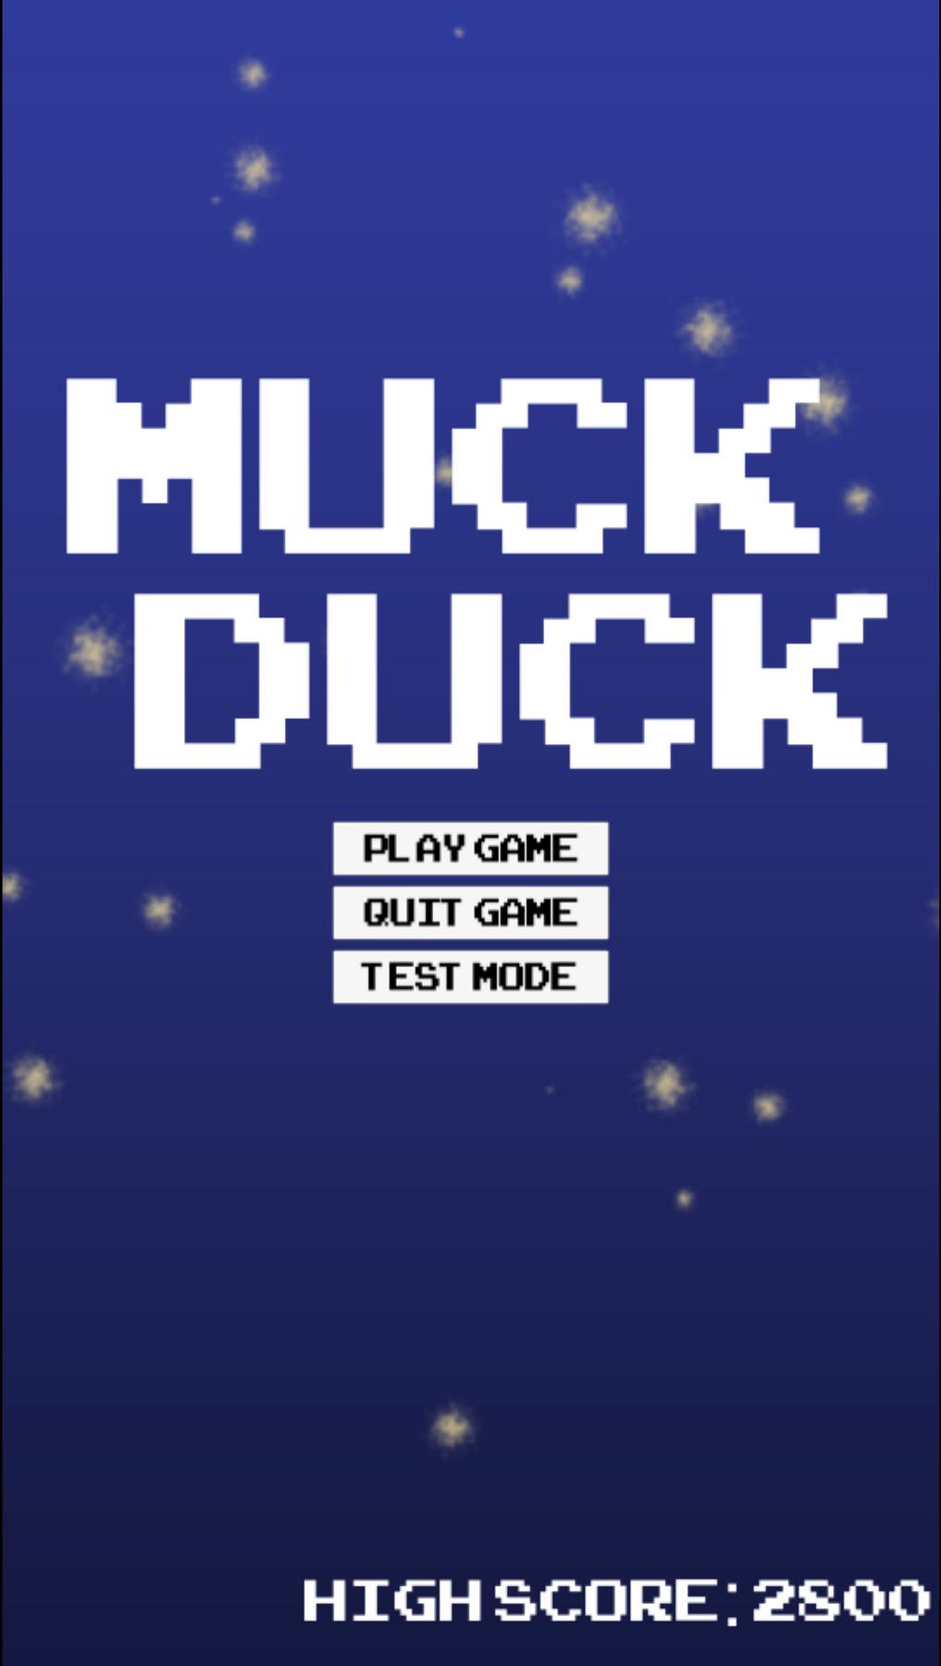

Notice the high score shows up here as well:
It can not be changed without playing the game

2.2 Game Play
Once you hit Play Game from the Main Menu start screen, the game will automatically begin. You will play as the duck object at the bottom of the screen. Your goal is to attack the random enemy bees that start to spawn from the top of the screen. To move your duck player, use the arrow keys in their respective direction. To shoot, hit the space bar key (mouse click may work as well) to attack the bees as you move through the galaxy.

You are given three lives to attack the bees. Every time an enemy bee
hits you, you lose a life and the game ends. At the end of the game,
you are given the option to restart with R or quit with Q (use your keyboard).
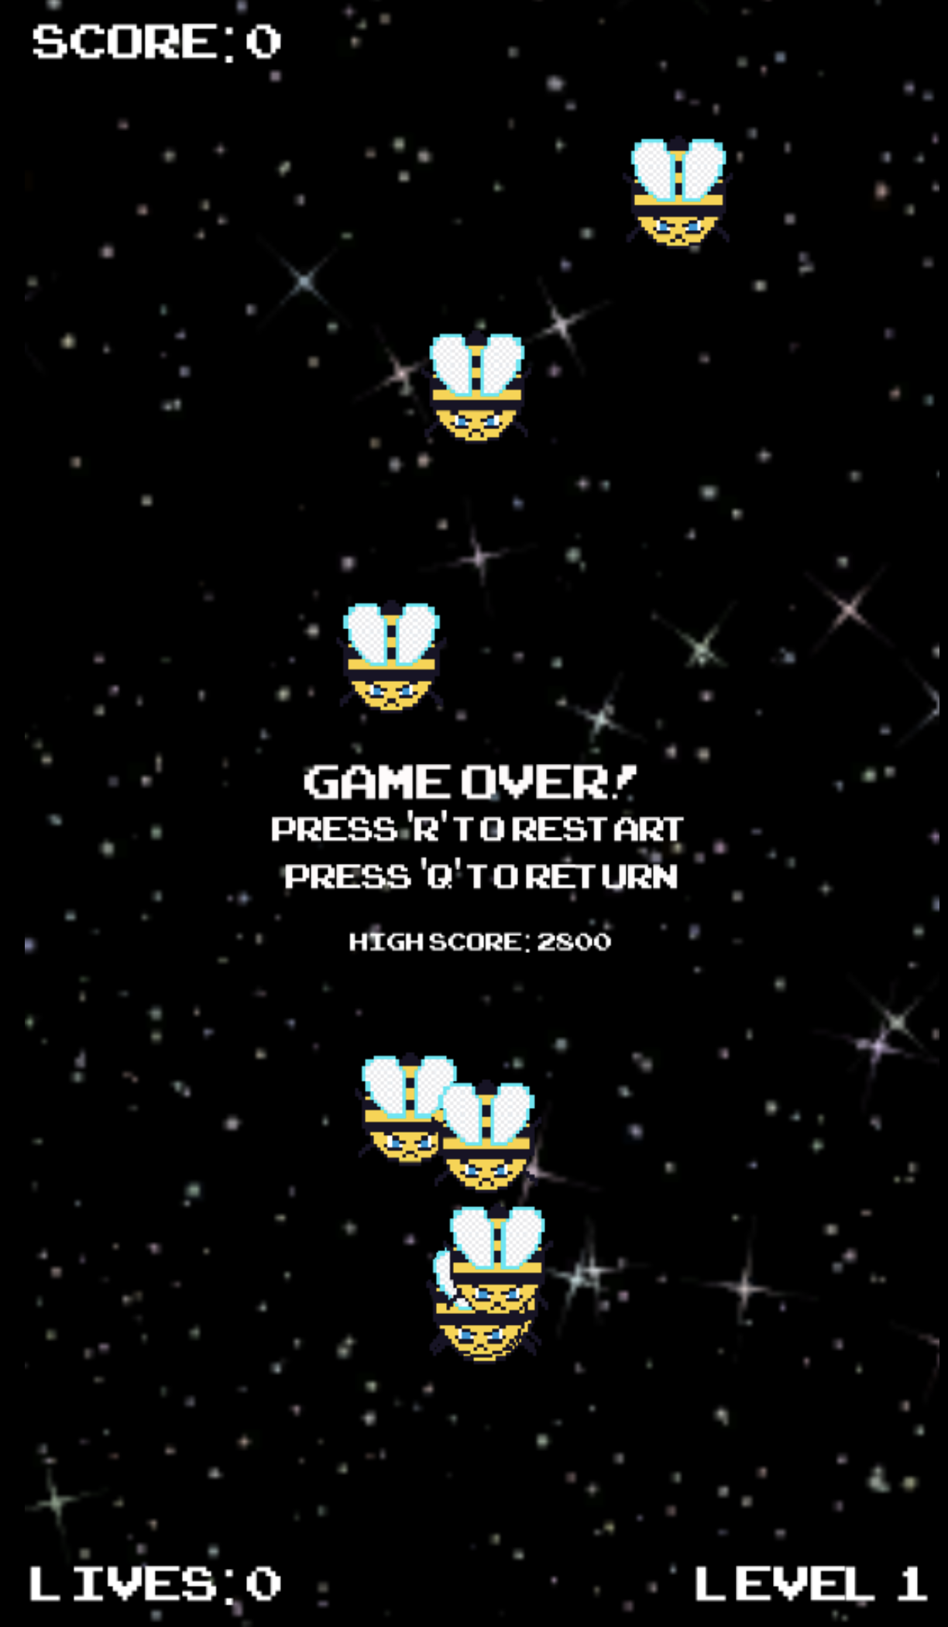

Throughout the game, a piece of bread will spawn from the left edge of the screen and travel through to the right of the screen before disappearing. This is a laser-shooting powerup. If you choose to, navigate the player duck to touch/pickup the bread piece to increase your speed of shooting for 10 seconds.

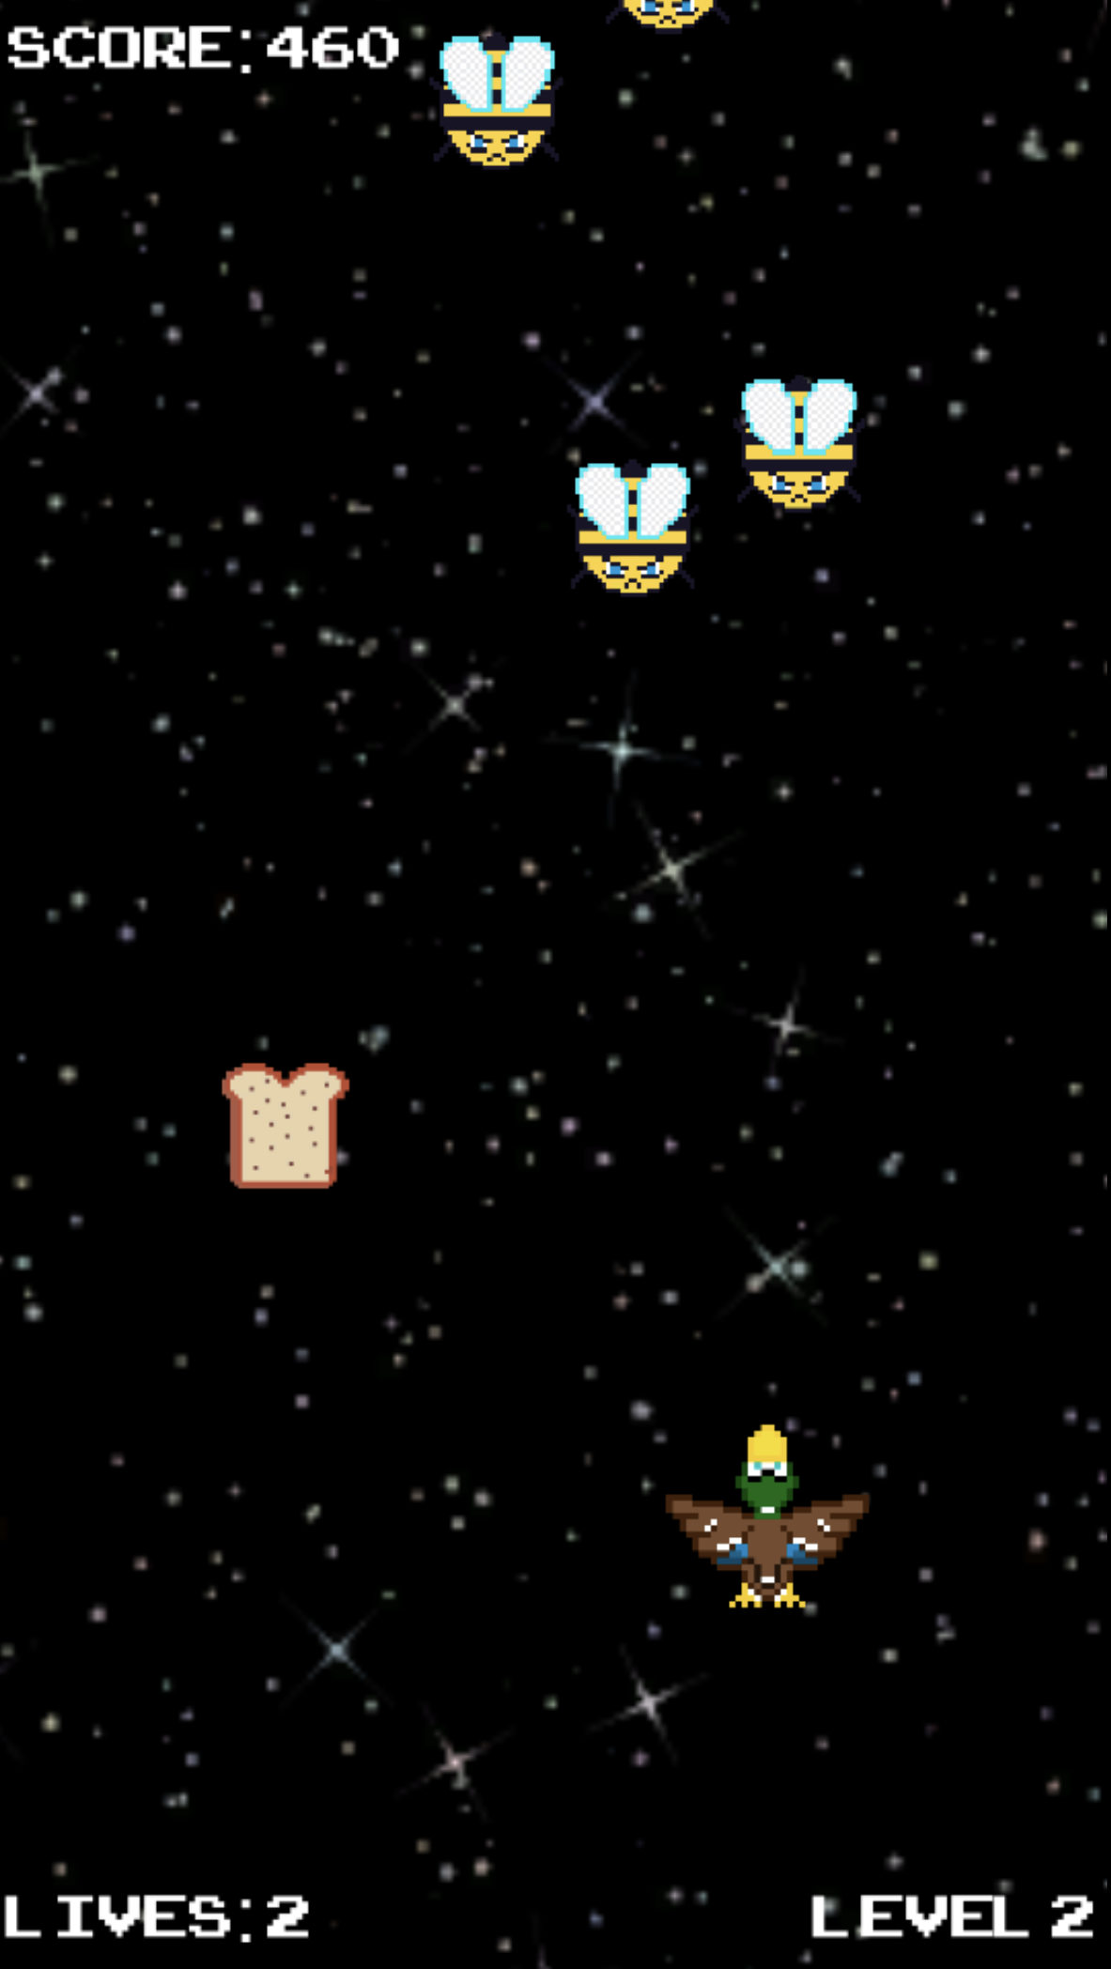

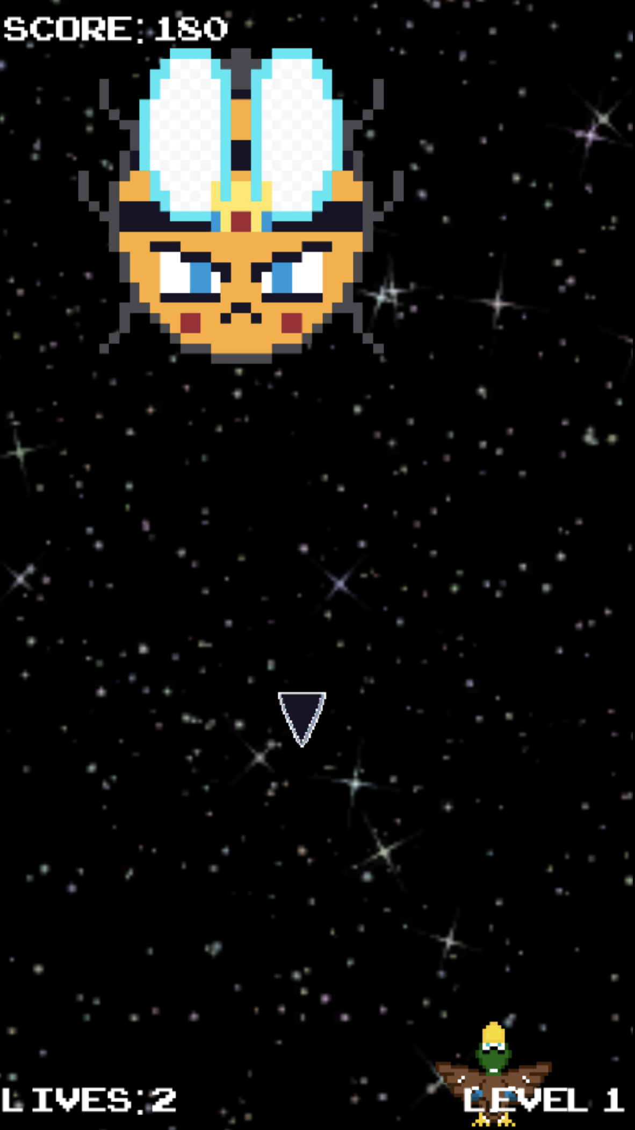
After a set amount of points, a Boss will appear. The boss is an enemy queen bee that can attack with her own projectile stingers. The goal is to kill the enemy bee’s health and progress to the next level upon killing her. Stay clear of her projectiles cause that can result in a loss of life as well. As the levels progress, the game increases in speed, as well as difficulty. Try your best to shoot through to earn the top high score on your tries.

2.3 Test Suite

On the start screen, if you choose test mode, you will be taken to a new mode of our game. The instructions and play will all be the same. However, while playing the game, tests will be run to ensure that all the game capabilities are intact and functioning as programmed. Our tests include checking the lives count of our player duck, ensuring that enemies disappear after being hit, and also checking to see that the powerup is picked up and working. The tests are run in real time as the game as being played. For instance, there is no way to check if lives are being lost if the player duck has not been attacked. So once a bee or boss projectile hits our player, the test will be triggered and ran to make sure it is properly functioning.

3.0 REFERENCES AND CITATIONS

References and citations

Below is a list of citations and references used in this project.

3.1 Citations

Music from : https://makeagame.bandcamp.com/album/sixty-minutes-free-music
https://opengameart.org/content/512-sound-effects-8-bit-style

Background screen from : https://opengameart.org/content/seamless-space-stars

Enemy, Bread, and Duck objects made by Ryan Pierce

Unity software with C# language to create framework and functionality of game

